Security Detection Framework
Electric Power Research Institute (EPRI)
April 24, 2024
By: Hunter Jones, Lucas Bowers, Ahmed Altouqi
ITEC 564 Capstone Project
Spring 2024
Integrated Information Technology
College of Engineering and Computing
University of South Carolina

Contents
Acknowledgment of the Client 2
Project Problem 3
Project Mission And Purpose 3
Project Process 3
Sprint 1 3
Sprint 2 4
Sprint 3 4
Sprint 4 4
Results 5
Limitations and Next Steps 5
Lessons Learned 6
Final Burndown and Burn-Up Chart 6

Acknowledgment of the Client
We wish to extend our appreciation to our clients, Christina Lawson, Jeremey Lawrence, and Jason Hollern, for allowing us to take on this insightful and significant journey together. Your invaluable feedback and partnership have been fundamental in the development of a framework dedicated to safeguarding power plants. It has truly been a pleasure to work with you and help create a product we can both be proud of. Thank you for the opportunity to work alongside you in this endeavor.

Project Problem
Many older-generation facilities don't have modern detection capabilities to spot and stop cyberattacks or unusual network activity. This is becoming a bigger problem because attackers are getting better tools to attack important infrastructure and hide what they're doing. There are also many detection products offered on the market that make claims to provide a wide range of capabilities and work with operational technology (OT) often found in generation facilities. Often multiple of these detection products are needed to create a well-rounded detection approach. It can be hard to understand what each generation facility needs to create a cost-effective detection plan that provides the right fit monitoring and detection.

Project Mission And Purpose
By building a detection framework, this project's main aim is to create a plan to help these facilities set up a well-rounded, cost-effective system to find and stop cyberattacks. The detection framework will be utilized to benchmark detection and detection-related tools that are useful to generation facilities and OT systems.

Project Process
The team utilized an agile scrum methodology consisting of the initiation, planning, execution, monitoring and finally closing phases. Hunter was the scrum master, Ahmed was the product owner, and Lucas was our development team. The first step of our project was to begin drafting our project charter to gain a better understanding of the client’s expectations and set out a goal for the end of the project, after agreeing with the client, the team developed a roadmap (project schedule) of the steps the team will take to ensure the project is a success, The team decided on Sprint 1 of the execution phase that we should gather enough information regarding OT and ICS systems, how they connect to IT and what kind of devices the client are already using. With the information the team conducted a basic framework on Excel with a list of questions that tested the capabilities of devices and that was our second sprint deliverable. Based on feedback from the client the team reworked the questions and added a further list of devices such as Host intrusion and Network instruction detection systems. Upon further feedback from the client, the team removed redundant questions, categorized those questions, and added examples of devices that could be used to perform that task. Once we received the okay from the client, the team started to work on documentation for the closing phase, Lucas was developing a visual to present at the expo and the team worked together to complete the final executive report.

SPRINT DELIVERABLES

Sprint 1
During Sprint 1, our primary focus was on conducting a thorough literary review. Firstly, we delved into the existing network framework established by EPRI. This involved studying the structure and components of their current network setup. Secondly, we familiarized ourselves with the essential functionalities of their existing network devices, gaining insights into their capabilities and limitations. Lastly, we dedicated time to examining the detection documentation provided by the company, while simultaneously initiating research into various devices and services that could effectively mitigate cyber risks. Our efforts culminated in compiling comprehensive research findings, which were subsequently shared with the Lead Liaison during our regular meeting sessions as per the Sprint 1 Deliverable requirement.

Sprint 2
The deliverable for Sprint 2 was to create a framework table that showed information regarding numerous network security devices and listed their capabilities. As a team, we decided that the best way to conduct this comparison would be to utilize Microsoft Excel to display the differences between security devices. We chose these types of devices because they are highly utilized in the cybersecurity space, and we believed that they could be assets implemented into an OT infrastructure. We provided the client with multiple options for each security device type and then received feedback regarding the framework. One of our liaisons thought that this framework was a good idea and gave him an idea for our 3rd sprint deliverable. The next deliverable would answer the “why” question as to why there were specific network devices chosen and this would lead us to the functional analysis that would be created in Sprint 3 to provide the “why” to Sprint 2.

Sprint 3
With the feedback received from Sprint 2, we were able to utilize the resources given to us combined with the feedback received to create a blueprint for our Sprint 3 deliverable. Our goal by the end of Sprint 3 was to have a high-level framework table that showed how different systems’ functionality acted regarding cyber security in an OT environment. This table compared numerous systems and utilized questions expanding from all realms of the OT environment to complete the functional analysis between security devices. After showing this product to the client they had some vital feedback that would make us alter our Sprint 4 deliverable. Our EPRI team advised us they would like to see a better-formatted, more in-depth analysis. Although the initial thought of the deliverable wasn’t negative as a team, we knew that this had to be revised in the next Sprint to create a product EPRI would truly enjoy.

Sprint 4
Coming into the closing weeks of the execution phase we were tasked with delivering an enhanced and cohesive iteration of our last Sprint’s framework table. Luckily, during this Sprint we would also be able to have a meeting with part of the EPRI team in person and take a trip around the EPRI plant to gain insight into the company and its OT setup. Before this trip, we would format our 3rd sprint deliverable in a way that the questions are more organized and provide ease of access to the user when utilizing the table. As for the content of the questions, our team provided an overhaul of numerous questions providing them with a more in-depth meaning. The last major addition to this framework in comparison to the 3rd deliverable besides more network devices is the addition of solutions for each of the given network tools. After these implementations, we had our initial client meeting regarding the Sprint 4 deliverable before submission to allow for feedback before the due date. In the meeting, our clients explained how they were expecting a more in-depth analysis and for us to utilize the resource given that was the MITRE d3fend framework as a reference to what sort of key areas should be on the finalized framework. After having this meeting and brainstorming ideas we were able to implement more sections and overhaul numerous questions to provide a more in-depth and in-line analysis that is more aligned with the client’s ideal solution.

Results
The final product is a finalized framework that features an analysis of network security devices and how their role in an OT infrastructure could be beneficial. Utilizing this framework, you will be able to see that no device covers an OT network 100% in each area. The best practice for this would be to implement multiple solutions to ensure you’re OT network is covered in numerous facets and can monitor, detect, and engage with malicious activity on the network effectively. As seen in the table many compatible pairings could provide ample protection to an OT framework. For example, our client could choose to implement a SOAR paired with an EDR to combat the areas a SOAR lacks effectiveness. Another example is a HID and a Next Generation Firewall to help in some of the network security and detection areas a HID doesn’t monitor as much. The functionality of this framework is to provide the client with key insights into the functionality of these devices so they can weigh their concerns and pick instruments that address them accordingly.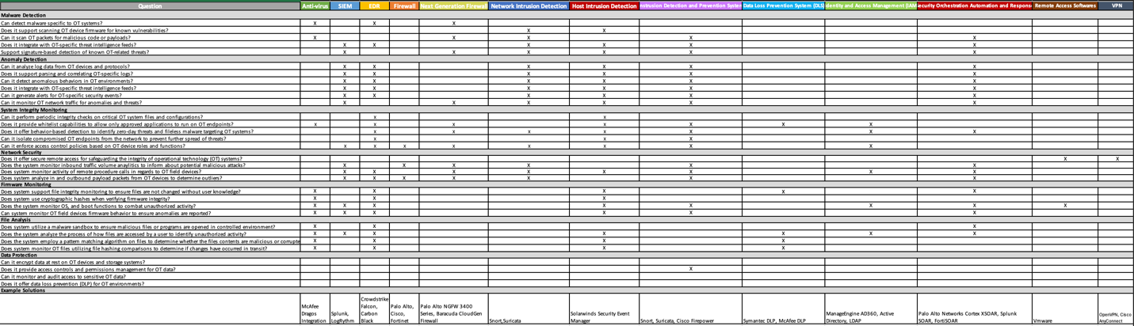

Limitations and Next Steps
Considering avenues for project extension and improvement, the inclusion of penetration testing stands out as a valuable enhancement. This would allow us to pinpoint specific areas needing improvement by testing what existing devices can and cannot detect, enabling tailored solutions. Given more time, we would expand our list of questions and categories for a more comprehensive assessment. While there are no identified pitfalls and this project has reached completion with no further phases, if we were to proceed with penetration testing, caution must be exercised to avoid any inadvertent disruption to client systems.

Lessons Learned
Reflecting on our project experience, the team gained valuable insights into operational technology (OT) infrastructure, from its layout to the capabilities of end devices. This hands-on learning enhanced our understanding of cybersecurity's detection aspect, highlighting its fundamental role. We also learned the importance of effective communication and teamwork in achieving project success and ensuring client satisfaction. Building the framework together reinforced these lessons and equipped us with practical skills for future endeavors. Overall, this project provided a solid foundation for our growth in cybersecurity and collaborative work.

Final Burn-down and Burn-Up Chart

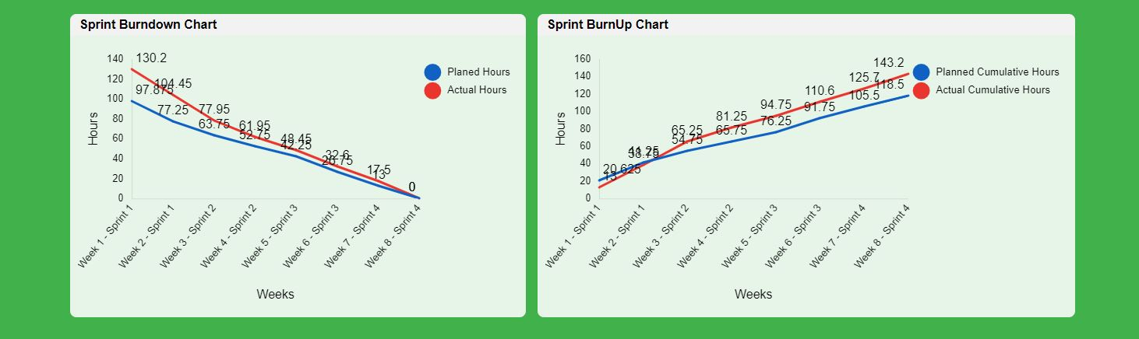

During Sprint 1, our actual hours were lower than planned because, during our planning phase, we allotted time for searching various sources to research OT. However, our client provided us with enough resources and courses to prepare the team for building the framework. During Sprint 2, the team's actual hours exceeded the plan as it was our first stage in drafting the framework. The team needed more time to conduct further research before implementing certain questions, and we also had to revisit our schedule to correct errors. In Sprint 3, the team's actual hours continued to surpass the planned hours due to errors in our project schedule when inputting hours. Additionally, the team researched various methods to enhance the framework and contacted customer support to verify the accuracy of the questions regarding their devices. Finally, during Sprint 4, the team further improved the framework based on last-minute feedback from our client. The team also began working on making the presentation at the expo less of a lecture by designing a visual through Microsoft Visio.

Appendices Included:
- Project Charter
- Project Schedule
- Project Poster
- Capstone Expo Presentation mp4. Format
- Each Sprint Deliverable

